**ASCII-MAN Reloaded**

Version 1

13 Mar 2020

**By Phil Bell**

fil_bell@hotmail.com

Discord: fil_bell

This is a Pac-Man clone written in AOZ Studio

**Game Play Features are as per the original Pac-Man game**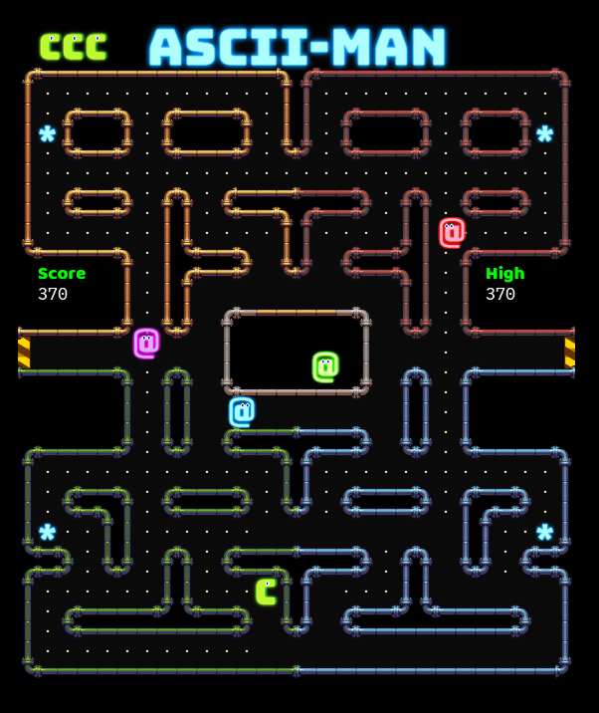

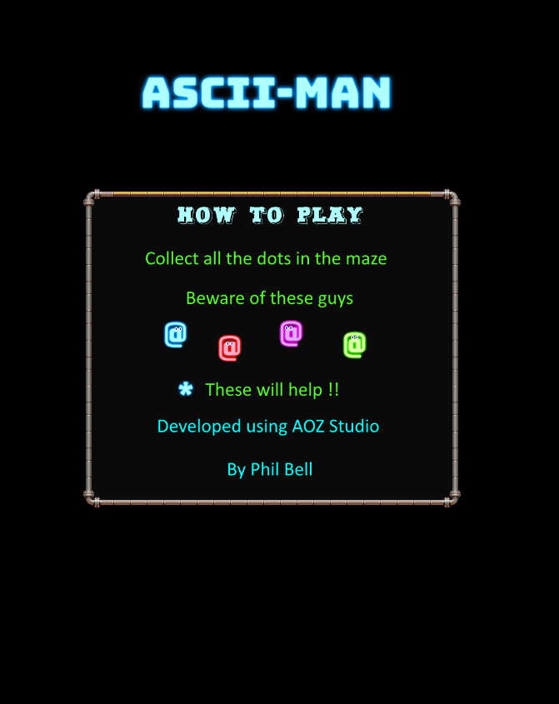

**Ghost “AI”**

(Red)

Aggressive find and chase the player

(Pink)

Ambush, target is 4 tiles in front of the player direction

(Green)

If player is more than 8 tiles away then target the player, else patrol scatter location (bottom left)

(Cyan)

Inky uses the most complex targeting scheme of the four ghosts in chase phase. He uses the players current tile/orientation and Blinky's current tile to calculate his final target**.**

**Game Play Features**

1. Player speeds up when cornering
2. Ghost frightened duration reduces as levels progress
3. Ghosts can not re enter ghost house
4. Player can not enter ghost house
5. Ghosts speed reduces when entering a tunnel
6. Player speed is slightly reduced when collecting dots
7. Captured ghosts must return to the ghost house to be revived, regardless if the game phase changes
8. Frightened duration decreases 1 second per level from 15 seconds in level 1
9. Normal ghost and player speed change depending on the current level
10. Ghost and player speed change when in frightened phase (super pill eaten)
11. Game phases and durations change from scatter to chase as per original game
12. There are 4 locations where ghosts can not turn up (13, 8) (16, 8) (13, 15) (16, 15), except when frightened
13. Ghosts can not make a U turn
14. Ghosts prefered direction is first up, then down, left, right when in frightened mode or when only 1 direction is valid
15. When ghosts are targeting a location, it turns to the location with the shortest distance to its target
16. Player points: Dot = 10, Super Pill = 50, Ghosts = 200 for first, then doubles for each after that, resets when frightened duration finishes
17. Fruit bonus - 2 per level, one when player has eaten 70 dots, another at 170, bonus stays in maze for 10 seconds
18. A ghost will be released if the player does not collect any dots for 5 seconds

**Game Phases:-**

|  |  |  |  |  |
| --- | --- | --- | --- | --- |
|  | Phases | Seconds | Seconds | Seconds |
|  | Mode | Level 1 | Levels 2-4 | Levels 5+ |
| 1 | Scatter | 7 | 7 | 5 |
| 2 | Chase | 20 | 20 | 20 |
| 3 | Scatter | 7 | 7 | 5 |
| 4 | Chase | 20 | 20 | 20 |
| 5 | Scatter | 5 | 5 | 5 |
| 6 | Chase | 20 | 1033 | 1033 |
| 7 | Scatter | 5 | 1/60 | 1/60 |
| 8 | Chase | indefinite | indefinite | indefinite |

**Fruit Bonus (2 per level, 1 at 70 dots collected, 2 at 170)**

|  |  |  |  |
| --- | --- | --- | --- |
| Level | Bonus | Points | ASCII |
| 1 | Cherries | 100 | **C** |
| 2 | Strawberry | 300 | **S** |
| 3 | Peach 1 | 500 | **P** |
| 4 | Peach 2 | 500 | **P** |
| 5 | Apple 1 | 700 | **A** |
| 6 | Apple 2 | 700 | **A** |
| 7 | Grapes 1 | 1000 | **R** |
| 8 | Grapes 2 | 1000 | **R** |
| 9 | Galaxian 1 | 2000 | **G** |
| 10 | Galaxian 2 | 2000 | **G** |
| 11 | Bell 1 | 3000 | **B** |
| 12 | Bell 2 | 3000 | **B** |
| 13+ | Key 1 | 5000 | **K** |

**Player and Ghost Speed**

|  |  |  |  |  |  |  |  |
| --- | --- | --- | --- | --- | --- | --- | --- |
|  | Player SPEED | | | | GHOST SPEED | | |
| LEVEL | NORM | NORM DOTS | FRIGHT | FRIGHT DOTS | NORM | FRIGHT | TUNNEL |
| 1 | 80% | 71% | 90% | 79% | 75% | 50% | 40% |
| 2 - 4 | 90% | 79% | 95% | 83% | 85% | 55% | 45% |
| 5 - 20 | 100% | 87% | 100% | 87% | 95% | 60% | 50% |
| 21+ | 90% | 79% | N/A | N/A | 95% | N/A | 50% |